
Lesson 14 Teacher's Key: Raising the Stakes
Unity - Instructor Reference Only
VIDEO GAME CREATION

What This Lesson Teaches
Same idea as every engine this week - replace hardcoded literals with wave-dependent formulas - expressed as C# expressions inside EnemySpawner.cs's SpawnEnemies() method.

Level 1 - Full Worked Solution
- int count = 4 + GameManager.wave computes the count once, then reuses it for both the loop and enemiesRemaining - a single source of truth by construction, not by discipline alone.
- No new fields are needed for Level 1 - this is purely a formula change inside a method that already exists.
- Wave 1 still spawns exactly 5 (4 + 1 = 5), so nothing about the game's opening feel changes - only later waves escalate.
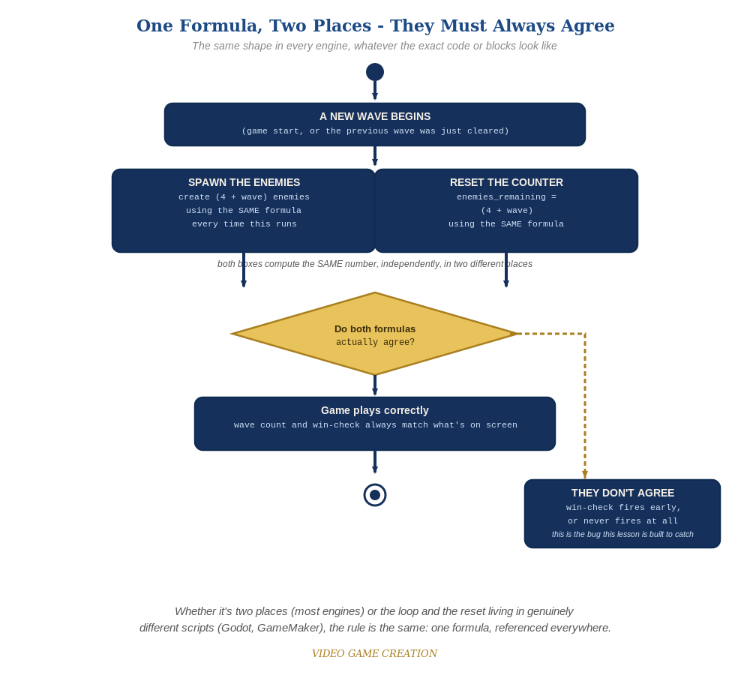
Whether the spawn loop and the reset live in two places or two genuinely different scripts, the rule is the same: one formula, referenced everywhere.

Why This Structure
- Storing count in a local variable (rather than repeating the (4 + GameManager.wave) expression twice) is good practice worth naming explicitly - it guarantees the loop and the reset value can never disagree, since they read the same computed value.
- For Level 2, setting each enemy's speed field right after Instantiate() (rather than changing the prefab's own default) keeps the scaling logic entirely inside SpawnEnemies() - Enemy.cs itself stays exactly as simple as Lesson 7 left it.

Level 2 / Level 3 Talking Points
- Ask students why storing count in a local variable is safer than writing the formula twice - a good, concrete illustration of avoiding duplicated logic.
- For students comparing engines: point out that GameMaker's identical (4 + wave) formula, expressed in GML instead of C#, is conceptually the exact same idea - a good cross-engine parallel.

Common Student Mistakes
- Writing the formula twice (once for the loop, once for enemiesRemaining) instead of storing it in a local variable - works if both are correct, but an easy place for a typo to cause disagreement.
- Forgetting GetComponent<Enemy>() when trying to set the new enemy's speed field, attempting to set it on the wrong object type.
- Leaving Enemy.cs's default public float speed = 1.5f as the ONLY place speed is set, forgetting the new per-instance override in SpawnEnemies() entirely.

